1.
2.
3.

Read the article at http://www.biography.com/people/ruby-bridges-475426 and record the Ruby Bridges story in 6 points.

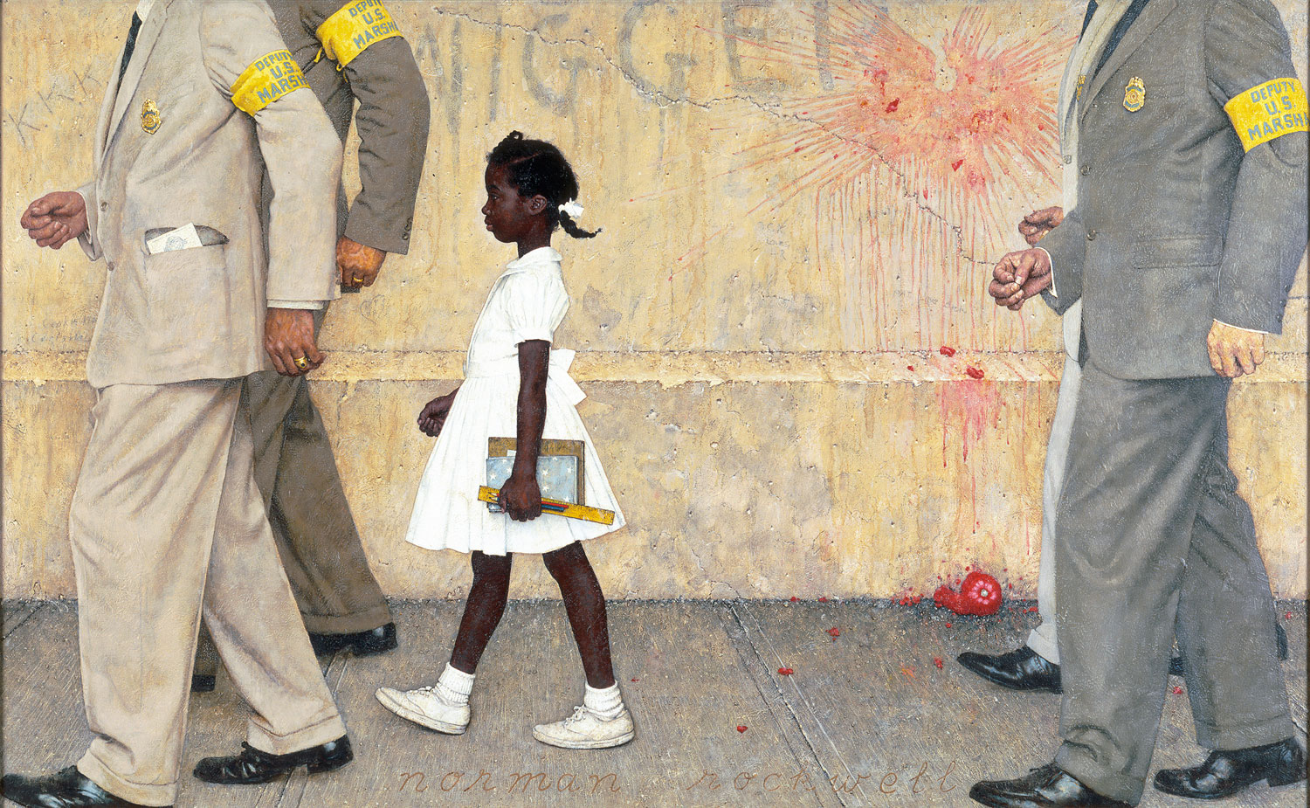
4.
5.
6.
“The problem that has no name” by Norman Rockwell.

